INSTRUCTION OF HOME PAGE

1. Objective

Briefly introduce the Regroupement and describe the responsibilities and vision of the organization ***Le Regroupement***. It should be noted that ***Le Regroupement*** is a platform and a bridge as well, which brings together and connects various resources of the aviation industry and promotes cooperation between different organizations, companies and institutions. Therefore, in the selection of images, slogans and texts, it is necessary to highlight the characteristics of ***Le Regroupement*** itself, and avoid highlighting a small number of companies too much.

2. Principles

2.1 **Responsive**. All pages should be responsive, that’s to say, each page can adapt to different platforms automatically.

2.2 **Reusable**. Design some components that can be reused, for example, the navbar and footer.

2.3 **Consistent**. Main colors, page layout, fonts, font size, etc, should be consistent.

2.4 **Accessible**. Implement the standards and requirements of WCAG 2.1.

2.5 **Well-organized SEO**. Implement key requirements of SEO.

3. Global settings

3.1 Key UI elements

body {font-family:”Roboto”; font-size:16px; background-color:#fff; }

:root{--title-grey: #383838; --prefix-blue:# 3572B5; --bg-green-light:# 77A643; --bg-green-dark:# 5F883F; --font-weight-light:300; --font-weight-bold:700; --font-weight-semibold:600;}

h1 {font-size:3rem;font-weight:var(--font-weight-bold);line-height:1.0;color:var(--title-grey);}

h2{font-size:2rem;font-weight:var(--font-weight-semi-bold);line-height:1.0;}

p {font-size:1rem; font-weight:var(--font-weight-light)}

a {text-decoration:none; cursor:pointer;}

li {list-style-type:none;}

*Reference link:*

i. fonts : <https://fonts.google.com/>

ii. responsive breakpoints: <https://getbootstrap.com/docs/5.1/layout/breakpoints/>

iii. accessibility (WCAG 2.1): <https://www.section508.gov/content/guide-accessible-web-design-development/>

iv. SEO: <https://blog.hubspot.com/marketing/seo>

3.2 Layout

This setting can make the footer sticked at the bottom of the page and keep the flexibility of header, content and footer.

<!DOCTYPE html>

<html>

<head>

<title>Page Title</title>

<style>

html,body{height:100%;padding:0;margin:0;box-sizing:border-box;}

.container{height:100%;display:flex;flex-direction:column;}

.sizing{ width:100%;max-width:1140px;margin:0 auto;}

.header{height:125px;background-color:var(--title-grey);}

.main{height:100%;display:flex;flex-direction:column;}

.flexible-height{flex-grow:1;flex-shrink:0;}

.footer{height:205px;background-color: var(--title-grey);}

</style>

</head>

<body>

<div class="container">

<div class="main">

<div class="header">

<div class="sizing"></div>

</div>

<div class="content flexible-height">

<div class="sizing"></div>

</div>

<div class="footer">

<div class="sizing"></div>

</div>

</div>

</div>

</body>

</html>

*Reference link:*

i. flexbox: <https://css-tricks.com/snippets/css/a-guide-to-flexbox/>

ii. layout: <https://material.io/design/layout/understanding-layout.html#principles>

4. Description of components

4.1 **Favicon**. Redesign the favicon according to the standards and methods in the reference article.

Reference link: <https://evilmartians.com/chronicles/how-to-favicon-in-2021-six-files-that-fit-most-needs#:~:text=Set%20the%20width%20and%20height,bit%20alpha%2C%20no%20palette%20settings.&text=Scale%20the%20image%20down%20to,and%20check%20the%20icon%20visibility>.

4.2 **Search field**. Search through the news and about-us using the key words entered by the user, display the result on another page. The search field is only activated when the user clicks on the search icon.



before

after

*Reference link*: <https://medium.com/@matswainson/building-a-search-component-for-your-next-js-markdown-blog-9e75e0e7d210>

4.3 **Navbar**. It should be responsive. The item has sub-nav uses a dropdown list. Each sub-nav is linked to an anchor of the destination page, not to a page.

*Reference link*: <https://getbootstrap.com/docs/5.1/components/navbar/>

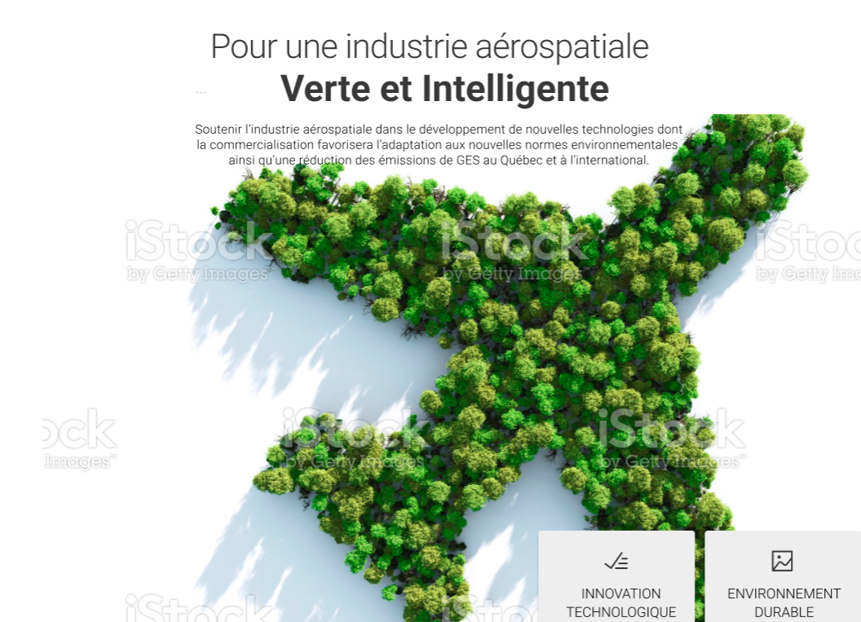4.4 **Hero image**. Two choices: a well-designed static image or a dynamic slides.

static image ( the image need to be designed to reflect the nature and vision of Le Regroupement). There’s no link on the image or images.

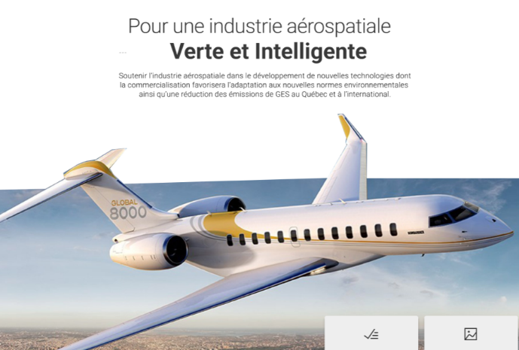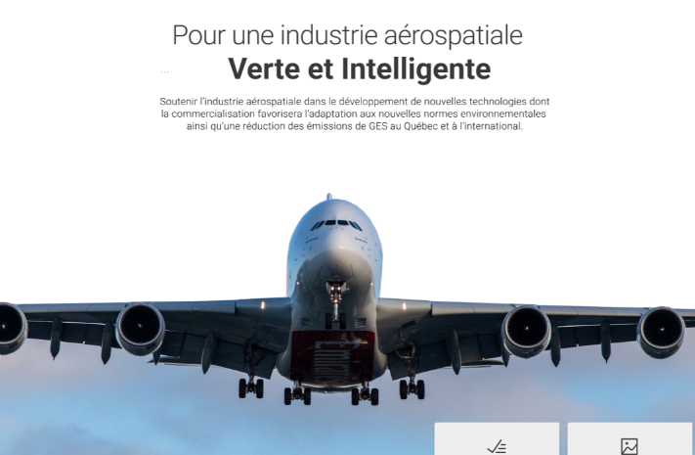dynamic slides (images should cover as many companies as possible which are partners of Le Regroupement, each image could have its own title)

*Reference link:*

i. hero image idea: <https://colibriwp.com/blog/hero-websites/>

ii. slides technique: <https://getbootstrap.com/docs/5.1/components/carousel>

4.5 Section of introduction of Le Regroupement. The ratio between the left part and the right part is about 6:4. They are responsive. On the small screen, the right part will be under the left part.

Reference link:

i. icons: <https://fontawesome.com/icons>

4.6 Section of industrial partners. The list is separated into 5 columns evenly and each cell has the same height. Each image has a link to the company’s website.

4.7 Section of reports. The gallery is with a hover effect. The report of 2021 is open by default. When the cursor hovers over a report, the image will have double width and three others single width.

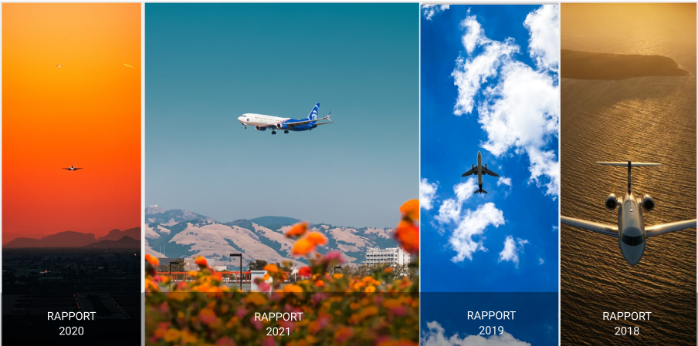

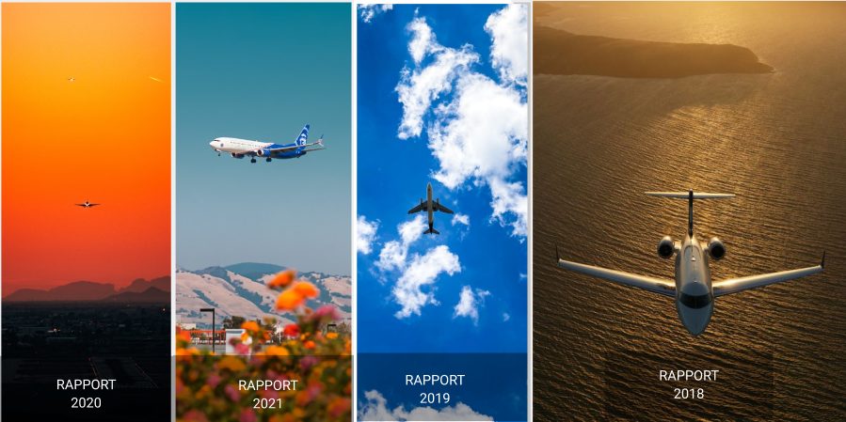

On the mobile device, display and unfold the images vertically with the same logic.

Reference link:

i. images: <https://unsplash.com>

ii. hover effects: <https://codepen.io/knyttneve/pen/YgZbLO>

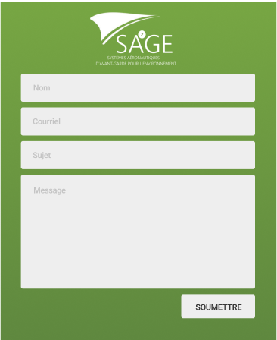4.8 Message box.

Two solutions:

i. Save all the information received from the message box into a database;

ii. Just send the information to an email address of the adminstrator of the website.

Reference link: <https://lo-victoria.com/how-to-build-a-contact-form-with-javascript-and-nodemailer>